SRS ON ATTENDANCE MANAGEMENT SYSTEM

#PREFACE

The Attendance Management System Report for 2022 is prepared for the TCSC according to the requirements of IEEE (Institute of Electrical and Electronics Engineers),

The report’s purpose is to

* To computerize the traditional way of taking attendance
* The Smart Attendance System aims to be a system of documenting student participation during a lecture
* It can generate a report automatically at the end of the session or in between of a lecture

#INTRODUCTION

* 1. Problem Definition:

The attendance management system takes input as students details, i.e. StudentID, Name, Surname, Roll No., Department, Class, Email, etc., number of lectures attended, number of practical conducted, number of lectures conducted.

* 1. Purpose:

Attendance Management System is a software developed for daily student attendance in schools, colleges and institutes. If facilitates to access the attendance information of a particular student in a particular class. The information is sorted by the operators, which will be provided by the teacher for a particular class. This system will also help in evaluating attendance eligibility criteria of a student. At the end of the semester, the system would provide with defaulters list which would help the respected teacher in charge to take a particular action

The following document describes the functional and non-functional requirements for the Attendance Tracking System release version 1.0. The contents are intended to be utilized by the class as guidelines for implementation and testing. This Software Requirements Specification Document only covers the main system and does not describe the implementation of the database in which the main system interacts. All the requirements stated in this document are slated for. Implementation in version 1.0. unless otherwise specified.

* 1. Intended Audience and Reading Suggestions

The intended audience is the students of Thakur College of Science and Commerce, who will be implementing and testing the attendance Management System. Also, the document is to be utilized by the professor to evaluate the software's design and features.

* 1. Product scope

The Attendance Management System will allow the teacher incharge to maintain a record of attendance of students in their respective classes from a PC. Also, the system will permit the teacher incharge to maintain all the essential details regarding a particular student . Furthermore, the program provides different modes to edit attendance, view statistics, and take notes on elements pertaining to attendance. The goal is to provide a professor with an easy, portable solution to attendance record maintenance and attendance statistics.

#OVERALL DESCRIPTION:

2.1 Product Perspective-

The Attendance Management System is intended to replace the manual model of attendance record keeping by means of roll call and paper records. The roll call and paper records are replaced with a single interaction between the professor and the Attendance Management System. Professors will be able to view details regarding attendance of individual students on their PC and quickly maintain attendance records. The features expressed in this Software Requirements Specification document are intended to be fully implemented in this version. We aim at an iterative development model to build our system. Iterative development model starts with full system, then changes functionalities of each subsystem with each new release. We have created our product development model by combining this feature of the Scrum model with the iterative model.

2.2 User Characteristic-

Students:

-Student must be of the same university as the teacher.

-Student must take the related courses in the semester.

-Student must know how to use the web application.

Teachers:

-Teacher must be of the same university as the student.

Teacher must give the related courses in the semester.

Teacher must know how to use the web application.

Administrator:

-Administrator must be of the same university as the student and the teacher

Administrator must have knowledge of software life cycle.

-Administrator must have knowledge of the mobile app and the web application.

2.3 Product Functions-

The main feature of the Attendance Management System is that it keeps a record of all essentials details of each individual student.

The first component mobile application is designed for the use of students. The students will register for application and then login. Students will be able to access the attendance list through the web application.

The second component is web application. Teachers can login to the system and then add the lessons they have opened during the semester and make the necessary arrangements. In the meantime, students and teachers can access the attendance list via web application.

At the end of a specified period this system creates a defaulters list as well as the non-defaulters list.

Attendance Percentage of each student in every subject would be displayed in this list Also, the system allows the professor to view pertinent statistics on student’s attendance record for the specified class. Finally, another feature of Attendance Management System is its flexibility and ease of use.

#SYSTEM ARCHITECTURE:

3.1 Requirement Specification:

3.1.1 Operating Environment

The Attendance Management System shall function on the PC provided by the college. This entails the system to operate on the Windows CE platform.

The Attendance Management System shall interface between Windows CE designated to store the attendance records. The Web Server and Database Software have not been established at this point.

The Attendance Management System will record all the essentials details of each particular student.

Pentium 3.0 GHz or higher RAM must be 1 Gb or more and Hard Drive 10 GB or more

3.1.2 Design and Implementation Constraints

The time allotted for this project will be limited to the end of this semester.

All the HTML code for the user manual will conform to the HTML 4.0 standard.

Programming is done in PYTHON, SQL, HTML, PHP.

3.2 EXTERNAL INTERFACE REQUIREMENTS

3.2.1 User Interfaces

The Attendance Management System shall provide details of students in the class to aid in taking roll.

These details can be clicked with a mouse in order to view a particular student’s attendance record.

All modifications to the database will be done through a keyboard.

Application will be accessed through a Browser Interface. The interface would be viewed best using 1024 x768 and 800 x 600 pixels resolution setting.

he program will provide a page that produces current statistics on class attendance

3.2.2 Hardware Interfaces

Server Side:

Operating System: Windows 7/xp ,Windows ME

RAM: 1 Gb or more

Hard Drive: 10 GB or more

Client side:

Operating System: Windows 7 or above, MAC or UNIX.

Processor: Pentium III or 2.0 GHz or higher.

RAM: 1 Gb or more

3.2.3 Software Interfaces

This software will transmit the attendance of a class to a database on a machinevia Internet.

The user will be allowed to modify attendance records at any time.

If the user forgets to transmit the information, the system will automatically send it for them at the end of the class.

Database

The Attendance Management System will communicate with the database to perform the following options:

To allow a user to enter attendance.

To allow a user to modify attendance.

To allow a user to query a system to gain statistics concerning individual and class attendance.

3.3 Non-Functional Requirements-

3.3.1 Performance Requirements:

The program must be able to be run concurrently by multiple professors. During peak times of usage (10:00 AM to 4:00 PM).

Transmission of roll data shall occur in under 5 seconds.

Acknowledgement of roll received (confirmation) shall be returned within 8 seconds.

Queries upon the database shall be performed in less than 5 seconds.

Upon start of the roll program, roll information shall be displayed on the instructor’ s PC within 10 seconds.

Email messages to absent students shall be sent within one hour of the conclusion of a class.

The program shall support taking roll for class sizes of up to 100 students. With a maximum class size, performance must still conform to all performance requirements.

3.3.2 Safety Requirements

System would be protected by a password.

As it is connected via LAN and MAN an antivirus has been installed on system for its safety purpose

3.3.3 Security Requirements

An instructor shall permitted to view and edit absence information in the database for only his/her classes.

In order to take roll or edit database information, the instructor shall be required to enter a password. This password shall be stored on the instructor’ s PC after initial entry in order that it must only be entered once.

Passwords shall be stored in an instructor database and verified upon each session of rollor database modification.

An instructor shall be allowed to change his/her password only by supplying his/her existing password. The updated password shall be stored in the instructor database andon the instructor’s PC.

4) System Models:

4.1) Object Flow Diagram

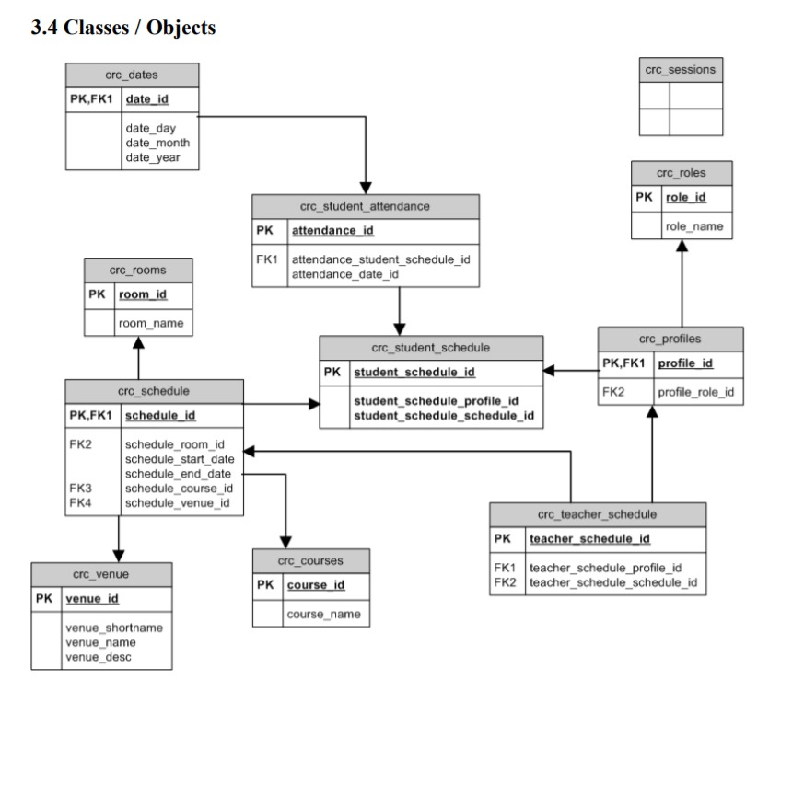

4.2) Data Flow Model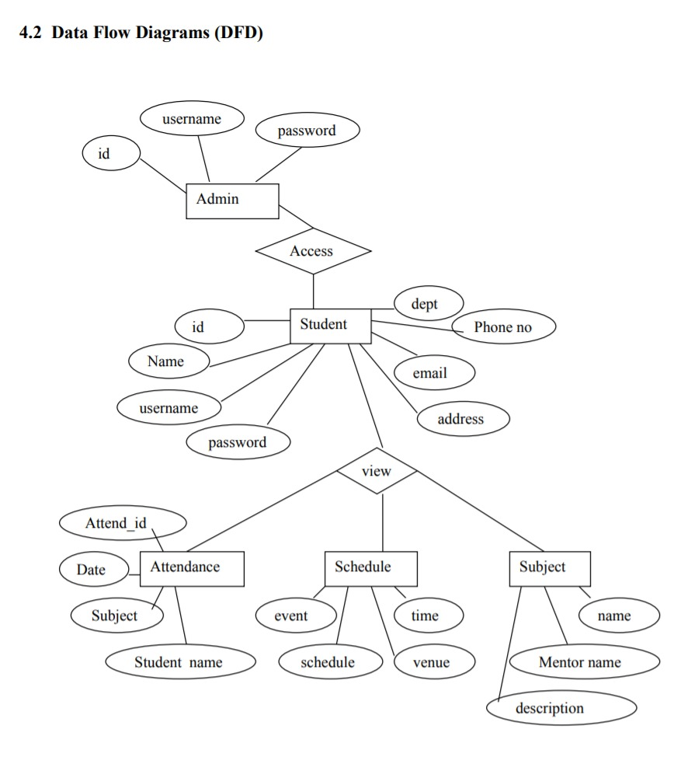

4.3) State Transition Diagram

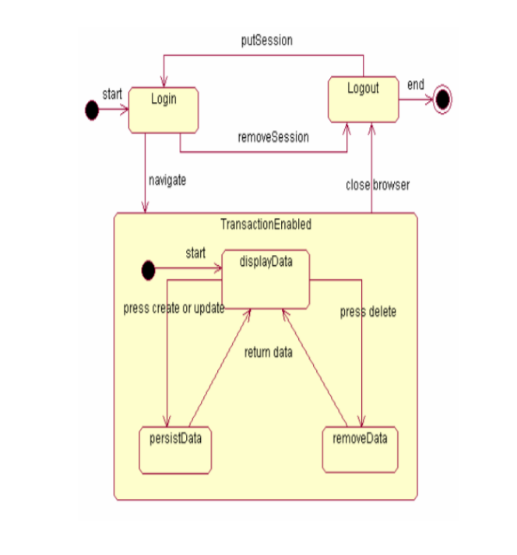

5) SYSTEM EVOULTION

5.1) Project Aim

This project aims to reduce the paper work and saving time to generate accurate results from the student’s attendance. The system provides with the best user interface. The efficient reports can be generated by using this proposed system. Advantages of Proposed System It is trouble-free to use. It is a relatively fast approach to enter attendance is highly reliable, approximate result from user best user Interface and efficient reports. Attendance Management System basically has two main modules for proper functioning Admin module is has rights for creating any new entry of faculty and student details. User has a rights of making daily attendance, generating report. Attendance report can be taken by given details of student details, date, and class.

5.2) Testing

Once source code has been generated, software must be tested to uncover (and correct) as many errors as possible before delivery to customer. Our goal is to design a series of test cases that have a high likelihood of finding errors. To uncover the errors software techniques are used. These techniques provide systematic guidance for designing test that Exercise the internal logic of software components, and Exercise the input and output domains of the program to uncover errors In program function, behavior and performance. Internal program logic is exercised using ―White box test case design Techniques. Software requirements are exercised using ―block box test case Design techniques. In both cases, the intent is to find the maximum number of errors with the Minimum amount of effort and time.

5.3) Maintenance

Software maintenance is far more than finding mistakes. Provision must be made for environment changes which may affect either the computer, or other parts of the computer-based systems. Such activity is normally called maintenance. It includes both the Improvement of the system functions and the corrections of faults which arise during the operation of a new system. It may involve the continuing involvement of a large proportion of computer Department recourses. The main task may be to adapt existing system in a changing environment. Back up for the entire database files are taken and stored in storage devices like Flash drives, pen drives and disks so that it is possible to restore the system at the earliest. If theirs is a breakdown or collage, then the system gives provision to restore database files. Storing data in a Separate secondary device leads to an effective and efficient maintains of the system. The nominated person has sufficient knowledge of the organization’s computer passed proposed change.

5.4)   Scope for future development

The project has a very vast scope in future. The project can be implemented on intranet in future. Project can be updated in near future as and when requirement for the same arises, as it is very flexible in terms of expansion. With the proposed software of database Space Manager ready and fully functional the client is now able to manage and hence run the entire work in a much better, accurate and error free manner.

6) APPENDICES

Glossary

SRS: Software Requirement Specification

RAM: Random Access Memory

OS: operating system

DB: Databases

PHP: Personal Home Page

SQL: Structured Query Language

HTTP: Hyper Text Transfer Protocol

Glossary

SRS: Software Requirement Specification

RAM: Random Access Memory

OS: operating system

DB: Databases

PHP: Personal Home Page

SQL: Structured Query Language

HTTP: Hyper Text Transfer Protocol

Glossary

SRS: Software Requirement Specification

RAM: Random Access Memory

OS: operating system

DB: Databases

PHP: Personal Home Page

SQL: Structured Query Language

HTTP: Hyper Text Transfer Protocol

Glossary

SRS: Software Requirement Specification

RAM: Random Access Memory

OS: operating system

DB: Databases

PHP: Personal Home Page

SQL: Structured Query Language

HTTP: Hyper Text Transfer Protocol

Glossary

SRS: Software Requirement Specification

RAM: Random Access Memory

OS: operating system

DB: Databases

PHP: Personal Home Page

SQL: Structured Query Language

HTTP: Hyper Text Transfer Protocol

Glossary

SRS: Software Requirement Specification

RAM: Random Access Memory

OS: operating system

DB: Databases

PHP: Personal Home Page

SQL: Structured Query Language

HTTP: Hyper Text Transfer Protocol

Glossary

SRS: Software Requirement Specification

RAM: Random Access Memory

OS: operating system

DB: Databases

PHP: Personal Home Page

SQL: Structured Query Language

HTTP: Hyper Text Transfer Protocol

Glossary

SRS: Software Requirement Specification

RAM: Random Access Memory

OS: operating system

DB: Databases

PHP: Personal Home Page

SQL: Structured Query Language

HTTP: Hyper Text Transfer Protocol

Glossary

SRS: Software Requirement Specification

RAM: Random Access Memory

OS: operating system

DB: Databases

PHP: Personal Home Page

SQL: Structured Query Language

HTTP: Hyper Text Transfer Protocol

Glossary

SRS: Software Requirement Specification

RAM: Random Access Memory

OS: operating system

DB: Databases

PHP: Personal Home Page

SQL: Structured Query Language

HTTP: Hyper Text Transfer Protocol

Glossary

SRS: Software Requirement Specification

RAM: Random Access Memory

OS: operating system

DB: Databases

PHP: Personal Home Page

SQL: Structured Query Language

HTTP: Hyper Text Transfer Protocol

Glossary

SRS: Software Requirement Specification

RAM: Random Access Memory

OS: operating system

DB: Databases

PHP: Personal Home Page

SQL: Structured Query Language

HTTP: Hyper Text Transfer Protocol

Glossary

SRS: Software Requirement Specification

RAM: Random Access Memory

OS: operating system

DB: Databases

PHP: Personal Home Page

SQL: Structured Query Language

HTTP: Hyper Text Transfer Protocol

Glossary

SRS: Software Requirement Specification

RAM: Random Access Memory

OS: operating system

DB: Databases

PHP: Personal Home Page

SQL: Structured Query Language

HTTP: Hyper Text Transfer Protocol

6.1) Glossary

Following abbreviations have been used throughout this document:

DFD: Data Flow Diagram

ERD: Entity Relationship Diagram

SRS: Software Requirement Specification

SQL: Structured Query Language

SMS: Student Management System

STD: State Transition Diagram